**Title: "Fruit Freshness: A Path from Tradition to Technology"**

***Abstract:***

This research paper explores the evolution of technology and methods for testing new fruits, tracing the evolution of traditional methods to modern developments. This paper talks about new ways to check if fruits and vegetables are fresh. It looks at different tools like cameras and sensors that measure things like colour and gas levels. The papers show how technology like RFID and microcontrollers are used for this. This paper also mention using machine learning to help detect fruit freshness. It take an in-depth look at a variety of methods that have been used for a long time, from visual inspection to the integration of technologies such as IoT, machine learning, deep learning and many more. By reviewing various research and innovations, we aim to provide an overview of the evolution of fresh fruit detection evaluation and illustrate the consequences, competition, and future prospects of these advances. Overall, the paper aims to give a simple summary of what's being done in this area and what might happen next.

**1. Introduction:**

Measuring fresh fruit is important to maintain food quality and safety standards. Traditional methods such as visual inspection and inspection by hand through touching the fruits or vegetables have limited accuracy and efficiency and often miss early signs of decay or contamination[21]. While traditional methods such as visual inspection and hardness testing lack accuracy and precision, modern technologies such as hyperspectral imaging, nose fire electricity, and smart packaging may be good for changing the environment[1][6]. This non-destructive technology can provide instant information to optimize storage, transportation and reduce waste by analysing colour, texture, oil composition and other new parameters, ultimately minimizing the impact on the environment while ensuring consumers receive quality and safe fruit.

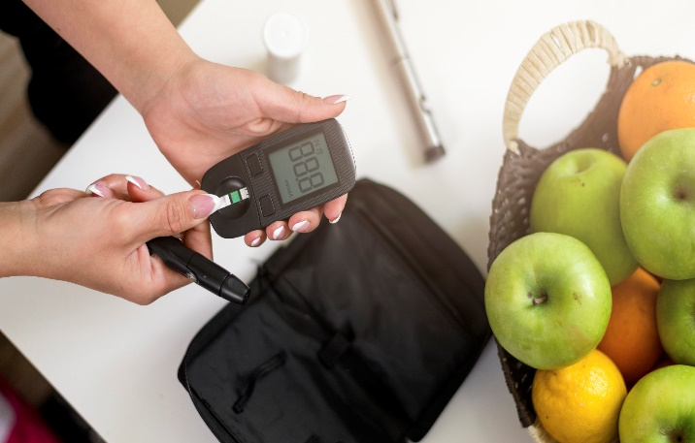 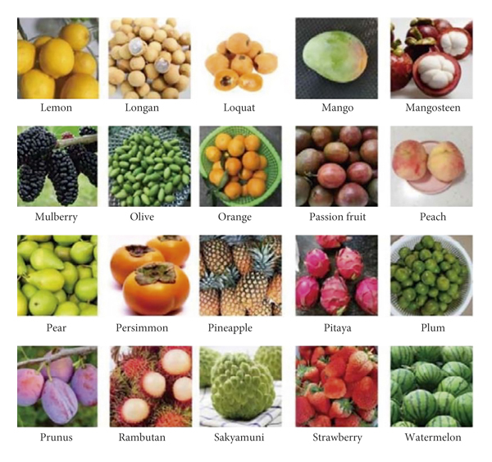

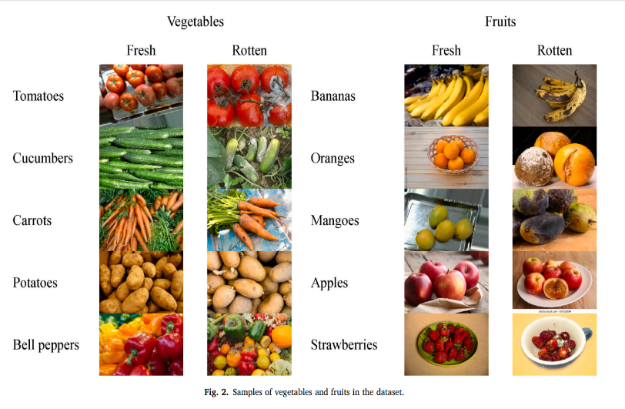

**This image is taken from ref no. [7]**

But modern technologies such as spectroscopy, imaging systems, and IoT sensors are providing unprecedented capabilities that are revolutionizing new discoveries. This technology does not affect the internal and external characteristics of the fruit, immediate care of the environment during storage and transportation, and decision-making process information. By using these advancements, those in the food industry can strengthen quality control, reduce waste, improve supply chain efficiency and ultimately ensure consumers receive fresh and safe fruit.

This technological revolution holds the promise of more nutritious, transparent and sustainable food for everyone.

**2. Literature Review:**

i. Traditional Methods for Fruit Freshness Detection:

Modern methods for evaluating fresh fruit include visual inspection, which relies on cues such as colour and texture to evaluate visually, and physical inspection, which counts by checking qualities such as stability and aroma through understanding. Chemical analysis also plays an important role, measuring parameters such as pH, acidity and sugar content to gain information about the interior of the fruit.

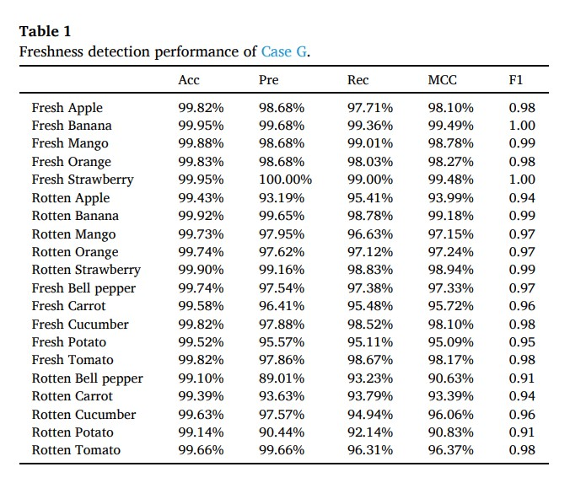

Even though these methods are commonly used, they take a lot of time and can't always catch fruits that are starting to go bad early on. This means we need better ways to make sure fruits are fresh. People usually rely on their senses and simple checks to tell if fruits are good. They look at them closely to see if there are any weird colours, spots, or wrinkles, and they also feel them to see if they're firm. But sometimes, these methods aren't perfect. They might not always learn from past mistakes, they can cause disagreements, and they might not be very accurate, especially when it comes to catching fruits that are just starting to spoil.

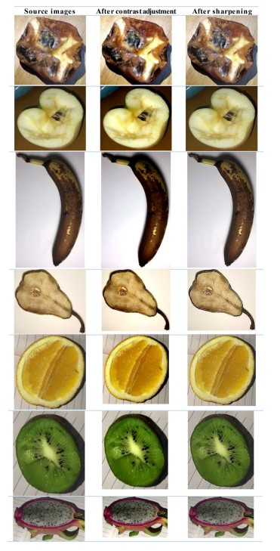

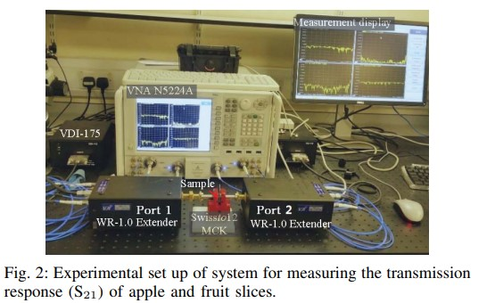

**This images is taken from ref no.[9]**

ii. Evolution of Techniques:

**This image is taken from ref no. [6]**

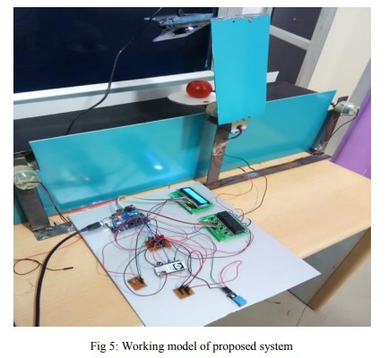

Significant progress has been made in the development of new fruit testing technology, including the integration of RFID technology that allows more oils to be analysed instantly in storage areas.

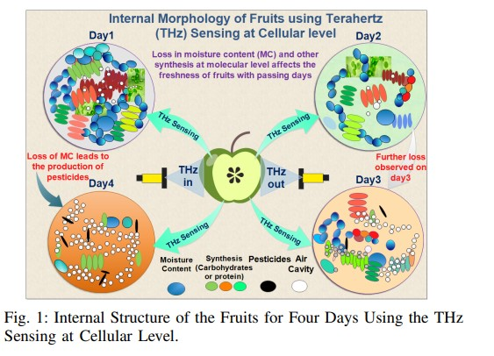

**This image is taken from ref no. [8].**

Additionally, the use of IoT devices can enable remote sensing and data collection, providing a better understanding of the environment that affects fruit quality.

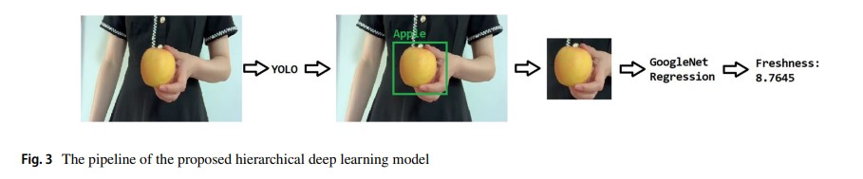

**This image is taken from ref no. [6]**

Machine learning algorithms are increasingly used in classification and prediction tasks, using large data sets to evaluate new metrics. Moreover, the adoption of deep learning models has transformed image-based evaluation towards new, more accurate and useful evaluation of external characteristics of fruit fruits.

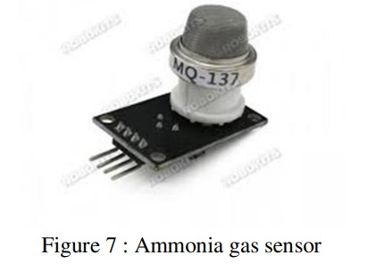

**This images are taken from ref no. [4]**

Together, these advances improve the ability to track and manage fresh fruit throughout the supply chain, ultimately improving food quality and safety standards. The evaluation of fresh fruit has become a significant change beyond traditional boundaries. RFID technology can instantly track the carbon monoxide emitted by the fruit, indicating the first stages of decay. IoT devices seamlessly integrate sensors into the supply chain to remotely collect important data on temperature, humidity and fuel levels. Machine learning algorithms analyse this data to automatically assign new levels and even predict shelf life.

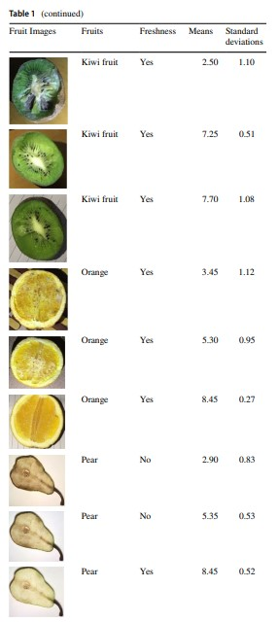

**This image is taken from ref no. [6]**

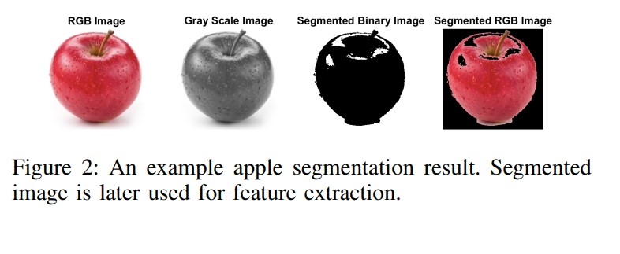

**This image is taken from ref no. [1]**

Deep learning models deliver unprecedented accuracy and intent, pushing the boundaries even further by using image recognition to evaluate new features based on subtle visual cues such as texture and colour changes. These advances represent progress in improving food quality, reducing waste, and ultimately protecting consumer health.

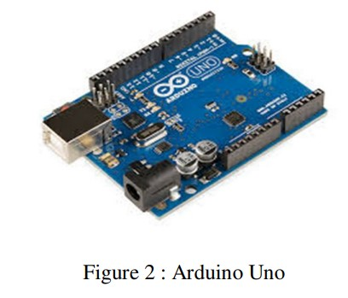

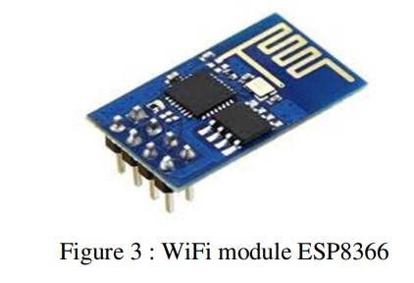

**This images are taken from ref no. [4]**

iii. Advancements in Modern Methods:

Today, recent advances in the search for fresh fruit have strengthened this field with the introduction of CNN-based methods that can classify fresh fruit and rot according to light with high accuracy. IoT-enabled systems are revolutionizing monitoring processes by making it easier to monitor environmental factors such as temperature, humidity and gas concentration to ensure optimal storage conditions.

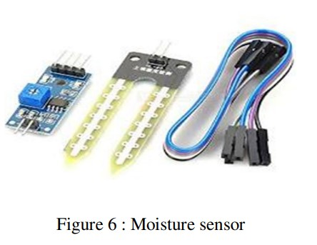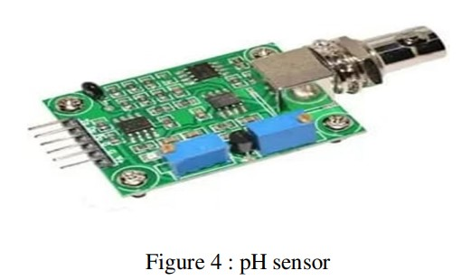

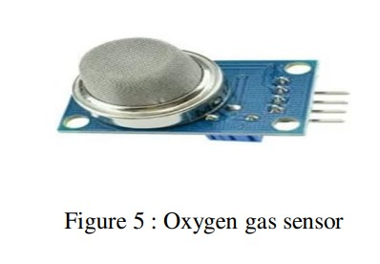

**This images are taken from ref no. [4]**

Integration of CMOS image sensors and edge processors enables high-speed detection of fruit freshness directly at the point of harvest or processing, increasing efficiency and reducing analysis time. Additionally, the development of deep learning models to solve resource utilization issues allows the search for new technology to spread over a longer period of time. Together, these advances represent a major step forward in ensuring food quality and safety in the fruit industry. The future of fresh fruit measurement is full of innovative solutions that push the boundaries of accuracy and efficiency.

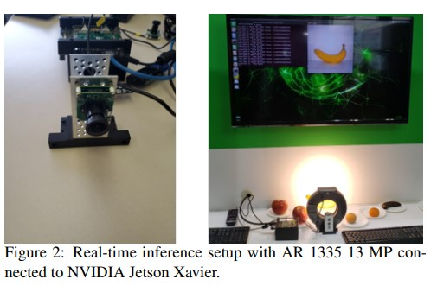

**This image is referred from ref no. [3]**

CNN-based method uses powerful deep learning algorithms to analyse images to achieve high-level classification of fresh fruit and rotten fruit, beyond the limitations of traditional methods. IoT-Enabled System Create a network of connected sensors that provide real-time information on temperature, humidity and fuel levels throughout the supply chain, allowing interventions to be made once agreed. Additionally, the integration of CMOS image sensors and edge processors into these systems enables rapid detection of the scene without the need for central computing, reducing latency and improving performance. The icing on the cake comes in the form of power-saving deep learning models to ensure these advances are sustainable and predictable and help create greener and more responsible foods. The combination of these technologies paints a promising picture for the future, ensuring food quality and safety, benefiting consumers, producers and the environment.

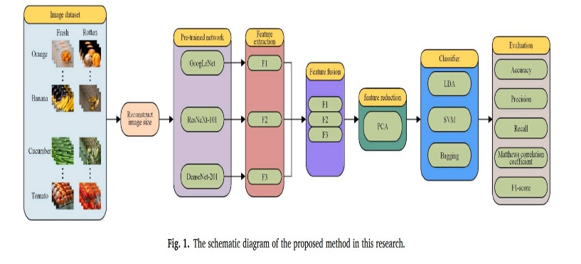

**This image is taken from ref no. [6]**

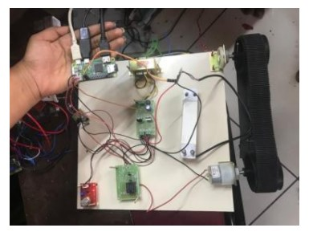

**This image is taken from ref no. [5]**

iv. Comparative Analysis of Methods:

Many things need to be considered when comparing fresh fruit methods. Different technologies vary in efficiency, effectiveness, and traditional methods are often more subjective and time-consuming compared to traditional output routines such as CNN-based methods and IoT-enabled systems that provide real-time monitoring and analysis. Accuracy, speed, and cost are important considerations when choosing a method. Although today's machines are more expensive, they often work better and faster than traditional methods. We must also consider different situations, such as where each method works best, such as a small business or a large business, and how many of us have the resources. Traditional methods are good for small businesses with limited resources, but new technologies are better for large businesses and complex situations. When we find new information, we must carefully check whether it is accurate, fast and appropriate. Traditional methods are well known but are not always suitable for large projects and sometimes people make mistakes when using them.

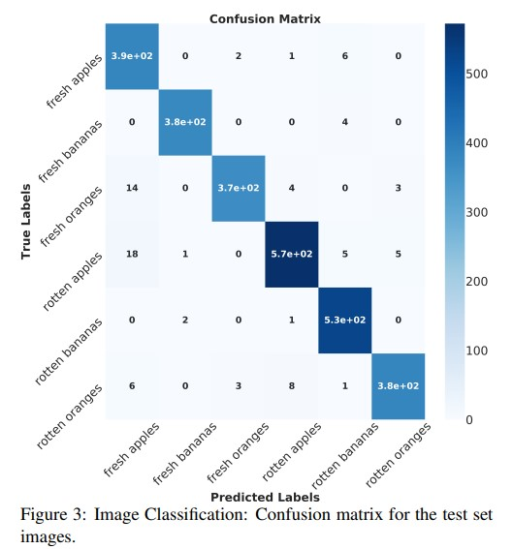  
**This images if referred from ref no. [3]**

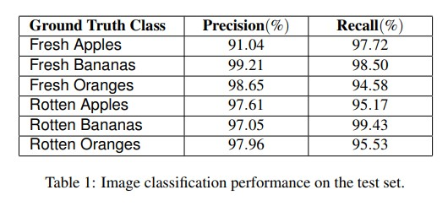

**This images if referred from ref no. [3]**

In contrast, modern methods such as CNN-based image analysis provide good accuracy for large datasets but can require significant resources. IoT-based monitoring is effective in real-time tracking of large equipment but affects real estate costs. Smart Packaging enables individual product tracking but faces challenges in design and integration. Finally, the best method depends on the situation: visual inspection will be sufficient for small farmers, while deep learning models electronic equipment for large suppliers can provide high inspection. Striking the right balance between quality, efficiency and cost in different areas is important to make the most of new technology in display construction. Good food and safety for all.

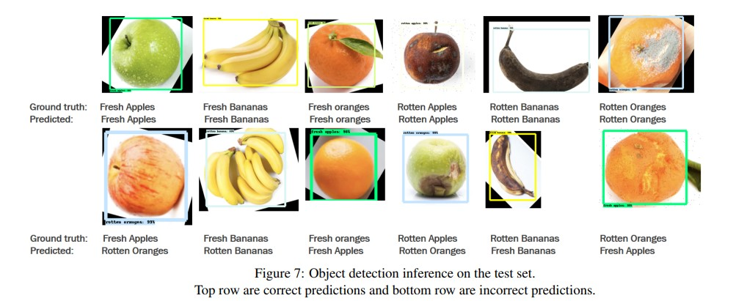

**This image if referred from ref no. [3]**

v. Challenges in Future Directions:

The challenges and future directions in testing new fruits are important for making food better and safer. We must ensure that our review is accurate and reliable by improving the data collection process and improving electronic equipment. Different applications such as agriculture and technology can bring us new ideas and solutions. We also need to continue to explore new technologies, such as the use of blockchain, to ensure that fruits can be tracked and secured. Although there are challenges such as ensuring that sensors work well and changing models according to different situations, working together and using new technologies can help us find solutions. By doing this we can ensure that the food we eat is good, safe and healthy for everyone.

3.FUTURESCOPE

In the future, advancements in technology will revolutionize how we detect fruit freshness. With sensors capable of analyzing fruit chemicals and smart machines learning patterns, we'll accurately determine when fruits are fresh. Connected devices monitoring temperature and humidity will ensure fruits remain fresh during storage and transit, while innovative packaging will change color or display information about fruit edibility. Inspired by nature, scientists will develop even better detection methods. Moreover, smartphones will host apps utilizing camera and software to assess fruit freshness instantly, providing tips on preservation and even discerning organic from chemically grown produce. This integration will not only simplify fruit freshness checks but also educate consumers about their food's origins and safety.

**4. Conclusion:**

In summary, this analysis discusses how we moved from the old method of testing new fruits to the use of new technologies that have led to major advances in the food industry. These new techniques, such as the use of cameras and smart sensors, can help us study fruits better. Not only do they make food safer and better, they also help save money and reduce waste. Those involved in the production and sale of food, such as manufacturers and consumers, can benefit from this technology as it produces reliable products and makes eating safer. By working together and generating new ideas, we can do these tests better in the future. New technologies such as smart cameras and computer studies are helping everyone in the food industry by making testing more efficient and effective. Working together to improve the way we collect data and ensure systems work efficiently will help provide better, healthier food for future generations.

# 5. Reference list

# Karakaya, D., Ulucan, O., & Turkan, M. (2019, October). A comparative analysis on fruit freshness classification. In *2019 Innovations in Intelligent Systems and Applications Conference (ASYU)* (pp. 1-4). IEEE. Karakaya, D., Ulucan, O., & Turkan, M. (2019, October). A comparative analysis on fruit freshness classification. In *2019 Innovations in Intelligent Systems and Applications Conference (ASYU)* (pp. 1-4). IEEE.

# Valentino, F., Cenggoro, T. W., & Pardamean, B. (2021, July). A design of deep learning experimentation for fruit freshness detection. In *IOP Conference Series: Earth and Environmental Science* (Vol. 794, No. 1, p. 012110). IOP Publishing.

# Ananthanarayana, T., Ptucha, R., & Kelly, S. C. (2020). Deep learning based fruit freshness classification and detection with CMOS image sensors and edge processors. *Electronic Imaging*, *2020*(12), 172-1.

# Borawake, M. P., Sharma, A., Shaikh, U., Barkade, S., & Paturkar, R. E-Gadget to Detect Food Freshness using IoT and ML.

# Jayasankar, K., Karthika, B., Jeyashree, T., Deepalakshmi, R., & Karthika, G. (2018). Fruit freshness detection using raspberry pi. *International Journal of Pure and Applied Mathematics*, *119*(15), 1685-1691.

# Fu, Y., Nguyen, M., & Yan, W. Q. (2022). Grading methods for fruit freshness based on deep learning. *SN Computer Science*, *3*(4), 264.

# Parmar, S., Manke, T., Badhan, N., Borase, P., & Ujgare, N. S. (2020). An Efficient System to Detect Freshness and Quality of Food. *IRJET) International Research Journal of Engineering and Technology*, *7*(4).

# Mariyam, S. J., Meghamala, M., & Meghashree, M. (2019, May). Automatized Food Quality Detection and Processing System Using Neural Networks. In *2019 4th International Conference on Recent Trends on Electronics, Information, Communication & Technology (RTEICT)* (pp. 1442-1446). IEEE.

# Ren, A., Zahid, A., Zoha, A., Shah, S. A., Imran, M. A., Alomainy, A., & Abbasi, Q. H. (2019). Machine learning driven approach towards the quality assessment of fresh fruits using non-invasive sensing. *IEEE Sensors Journal*, *20*(4), 2075-2083.

# Mudaliar, G. (2021). A System To Detect Fruitfreshnessusingmachine Learningand Iot Approach. *Turkish Journal of Computer and Mathematics Education (TURCOMAT)*, *12*(12), 2469-2477.

# Valentino, F., Cenggoro, T. W., Elwirehardja, G. N., & Pardamean, B. Energy-efficient deep learning model for fruit freshness detection. *Int J Artif Intell ISSN*, *2252*(8938), 1387.

# Kang, J., & Gwak, J. (2022). Ensemble of multi-task deep convolutional neural networks using transfer learning for fruit freshness classification. *Multimedia Tools and Applications*, *81*(16), 22355-22377.

# Haque, M. M., Ahmed, R., Saha, S., Saha, C., & Dutta, M. (2022). *Fruit and vegetable freshness detection using deep learning* (Doctoral dissertation, Brac University).

# Bhargava, A., & Bansal, A. (2021). Fruits and vegetables quality evaluation using computer vision: A review. *Journal of King Saud University-Computer and Information Sciences*, *33*(3), 243-257.

# Ren, A., Zahid, A., Zoha, A., Shah, S. A., Imran, M. A., Alomainy, A., & Abbasi, Q. H. (2019). Machine learning driven approach towards the quality assessment of fresh fruits using non-invasive sensing. *IEEE Sensors Journal*, *20*(4), 2075-2083.

# Ismail, N., & Malik, O. A. (2022). Real-time visual inspection system for grading fru its using computer vision and deep learning techniques. Information Processing in Agriculture, 9 (1), 24–37.

# Butz, P., Hofmann, C., & Tauscher, B. (2005). Recent developments in noninvasive techniques for fresh fruit and vegetable internal quality analysis. *Journal of food science*, *70*(9), R131-R141.

# Sarmah, B., & Aruna, G. (2020, August). Detection of food quality and quantity at cold storage using IoT. In *2020 International Conference on Wireless Communications Signal Processing and Networking (WiSPNET)* (pp. 200-203). IEEE.

# Ni, J., Gao, J., Deng, L., & Han, Z. (2020). Monitoring the change process of banana freshness by GoogLeNet. *IEEE Access*, *8*, 228369-228376.

# Nturambirwe, J. F. I., & Opara, U. L. (2020). Machine learning applications to non-destructive defect detection in horticultural products. *Biosystems engineering*, *189*, 60-83.

# Harsh, A., Jha, K. K., Srivastava, S., Raj, A., & Raghav, S. (2020). Fruit freshness detection using CNN approach. *International Research Journal of Modernization in Engineering Technology and Science*, *2*(06).

# Saha, A., Ali, L., Rahman, R., Hossain, T., Shamim, S. J. M. B., Supto, M. A. A., ... & Hasan, M. (2023, August). IoT Based Fruit Quality Inspection and Lifespan Detection System. In *2023 7th International Conference On Computing, Communication, Control And Automation (ICCUBEA)* (pp. 1-6). IEEE.

# JHA, S. N., & MATSUOKA, T. (2000). Non-destructive techniques for quality evaluation of intact fruits and vegetables. *Food Science and Technology Research*, *6*(4), 248-251.

# Warsiki, E., & Rofifah, N. (2018, December). Dragon fruit freshness detector based on methyl red colour indicator. In *IOP Conference Series: Earth and Environmental Science* (Vol. 209, No. 1, p. 012016). IOP Publishing.

# Baietto, M., & Wilson, A. D. (2015). Electronic-nose applications for fruit identification, ripeness and quality grading. *Sensors*, *15*(1), 899-931.